

**EXPERIMENT – 2.3**

**CONTROLLING WS2812 RGB LED WITH REMOTE**

**What will you learn from this module**:

Control the different colours of ring led with remote.

**Requirements:**

* nRF connect for desktop software.
* nRF Command line tools.
* Visual studio code.
* USB cable.
* nRF52832 development board.
* WS2812 RGB led.
* Remote (NODE).

**Prerequisites:**

* Basic knowledge of C/C++
* Basic knowledge of communication protocol.
* Basic project setup.

**Setup and Configuration**:

* Open VS Code and click on **Open Existing Application [1]** > click on **transimter(nrf52832) [2]** > **Open [3]** as shown in the picture below.

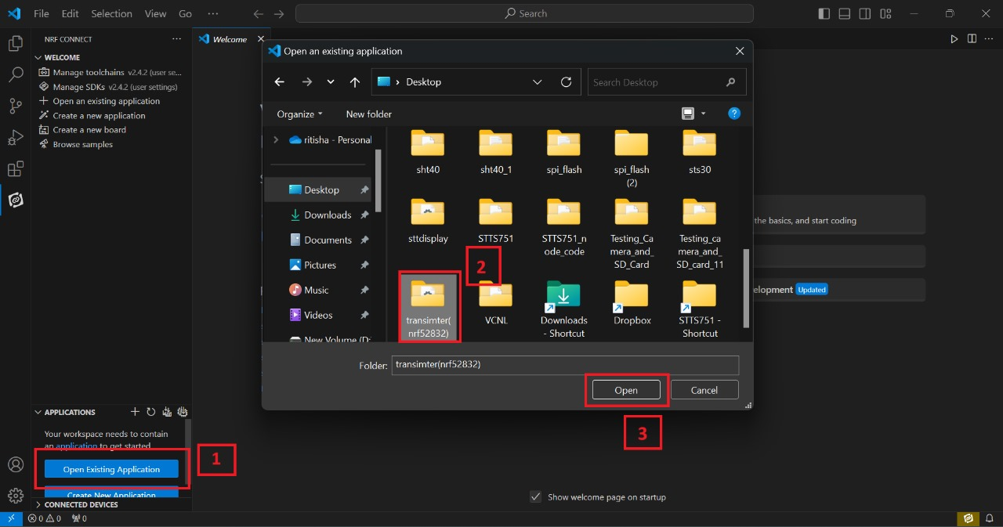

* Click on **Create new build configuration [1]**. Here you can change the board version, if you are using nRF52832, then select **nrf52dk_nrf52832 [2]** or you can change from dropdown menu for another version like nRF52833 etc.
* Click on the Configuration and select **prj.conf [3]** from dropdown menu and then click on the **Build Configuration [4]** as shown below in the picture.

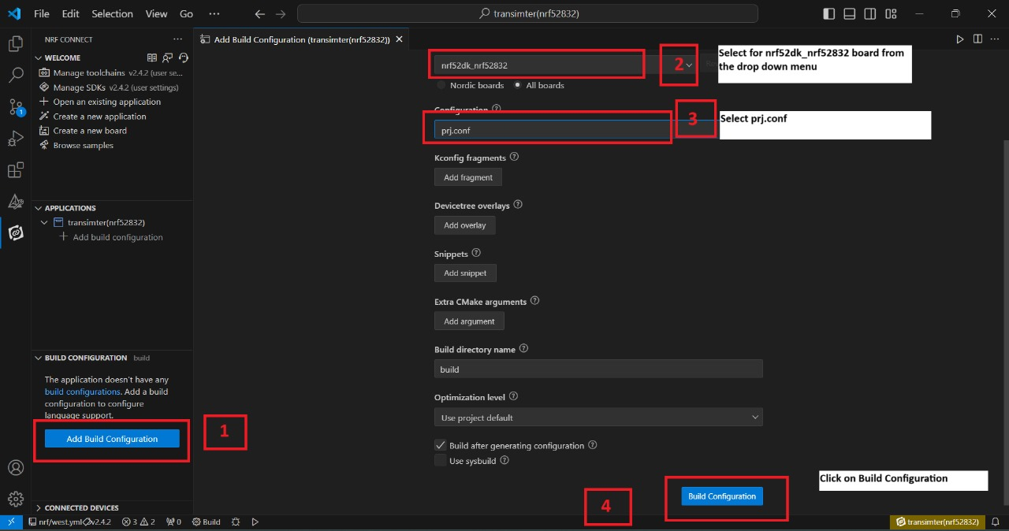

* Go to source file, click **source file [1]** > click on **Application** > click on **src** > click on **main.c [2]**.
* By Clicking on **main.c** file and you will see the code on your screen **[3]**.

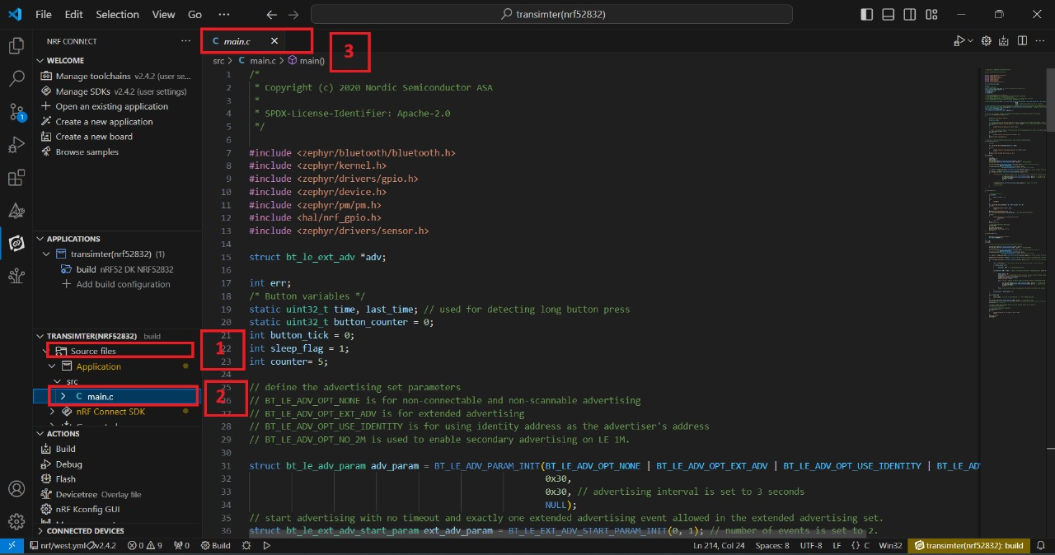

* To configure the prj configuration, click on **Config files [1]** > click on **Kconfig** > click on **prj.conf [2]**.
* The prj configuration will appear on your screen **[3]** as shown in the picture below.

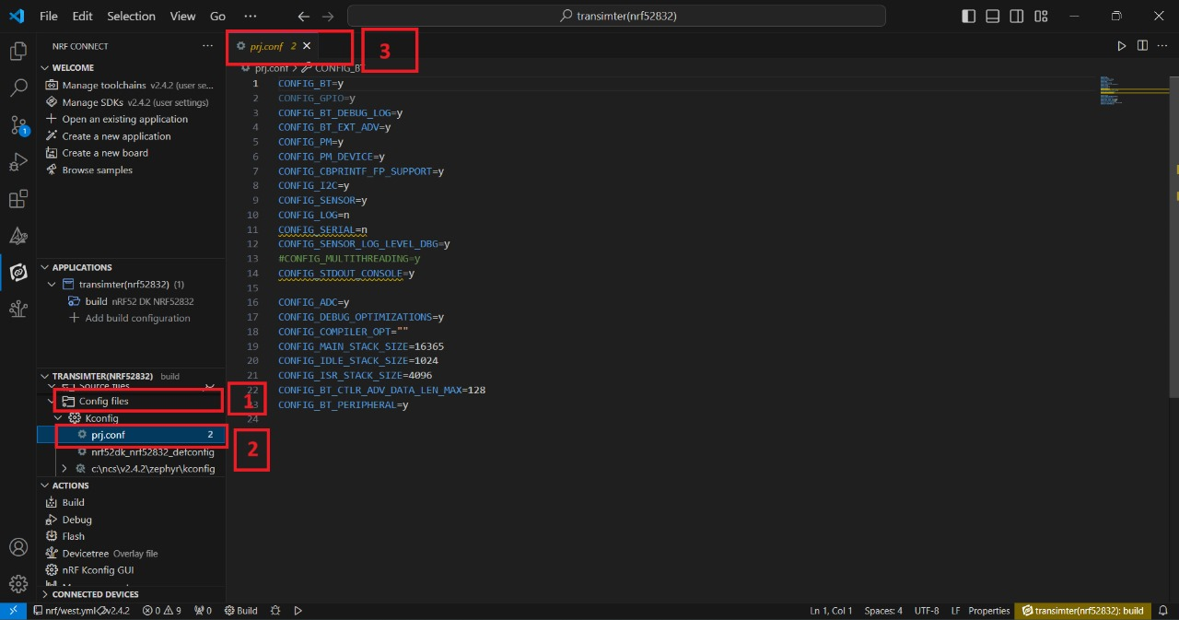

* Click on the **Config files [1]** > click on **Kconfig** > click on **Devicetree [2]** > click on **nrf52dk_nrf52832.overlay [3]**.
* The .overlay file will appear on your screen and add the given code to the .overlay file as shown in the picture given below **[4]**.

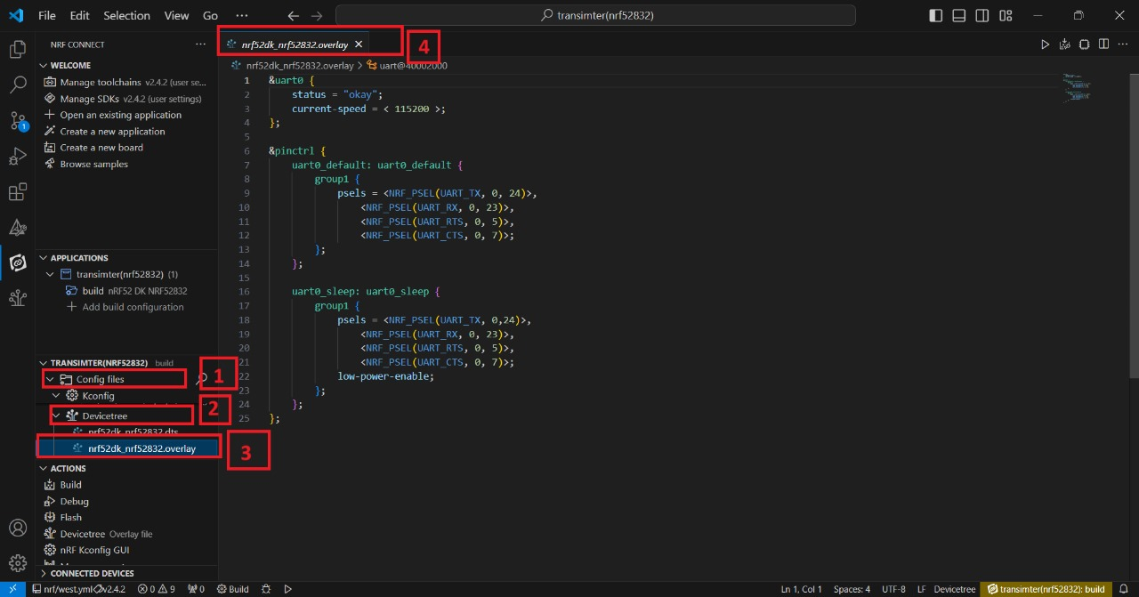

* Click on **Config files [1]** >then click on **Devicetree** > click on **nrf52dk_nrf52832.dts** [2]
* The **dts file** will appear on your screen and add the details in your **dts file** as shown in the picture given below **[3]**.

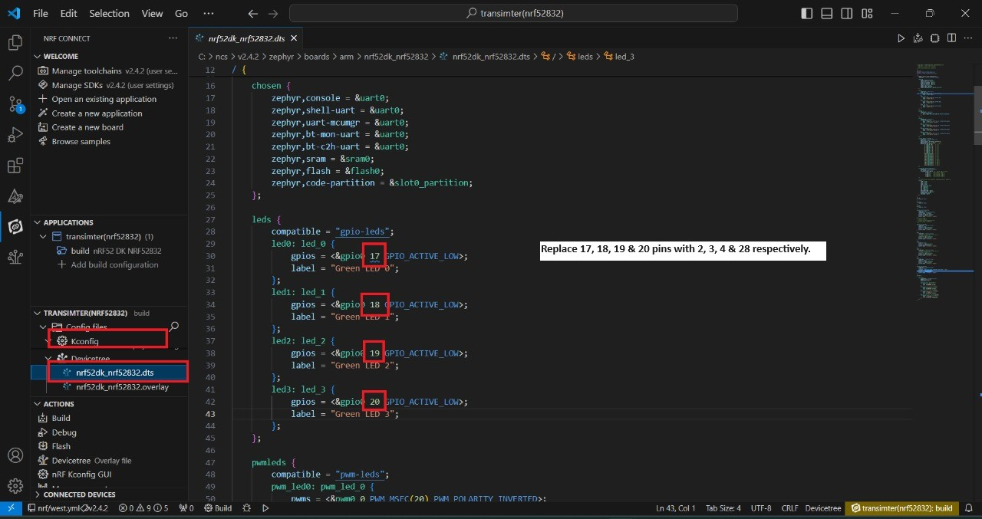

* For Node programing remove the jumper **J2** from the development board.
* Now flash the code with the help of nRF52832 development board as shown below in the figure.

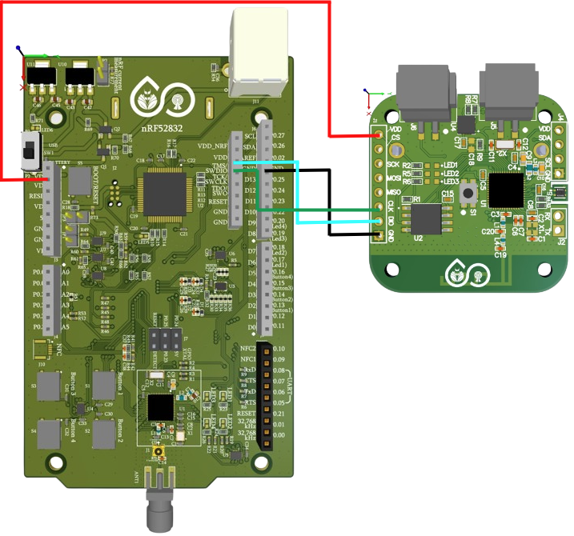

**Board Pins -> NODE Pins**

**VDD(3.3V) -> VDD**

**GND -> GND**

**CLK -> CLK**

**DIO -> DIO**

**Remove the jumper J2 from here.**

* There is another way of flashing the code with the help of Node Programmer as shown in the picture below.

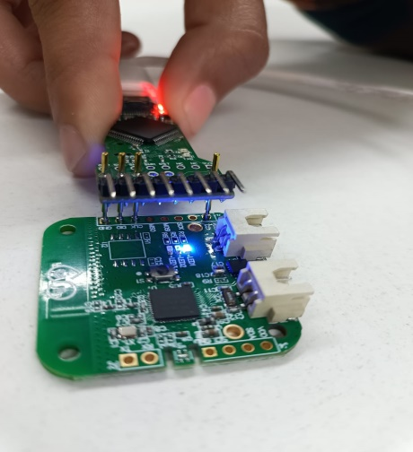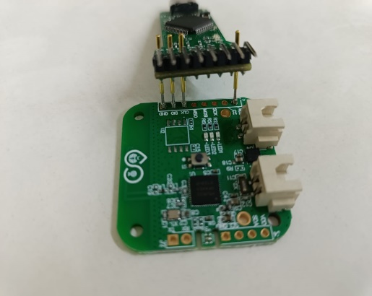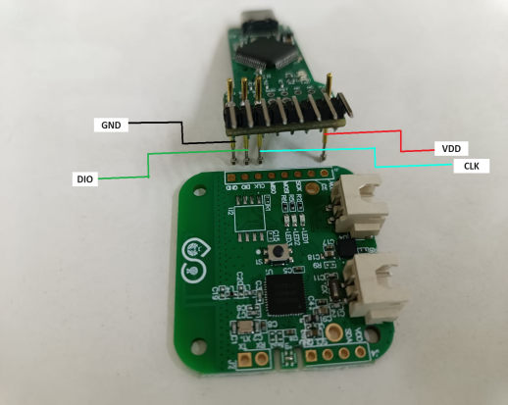

* NODE after program.
* NODE with connection.
* NODE without connection.
* Click on **Build [1]** configuration again and check the **CONNECTED DEVICES [2]**.
* If device id is visible, then **Flash [3]** the code in Dev Kit.
* If **flashed successfully [4]** message is displayed on serial terminal, then flash process is complete.

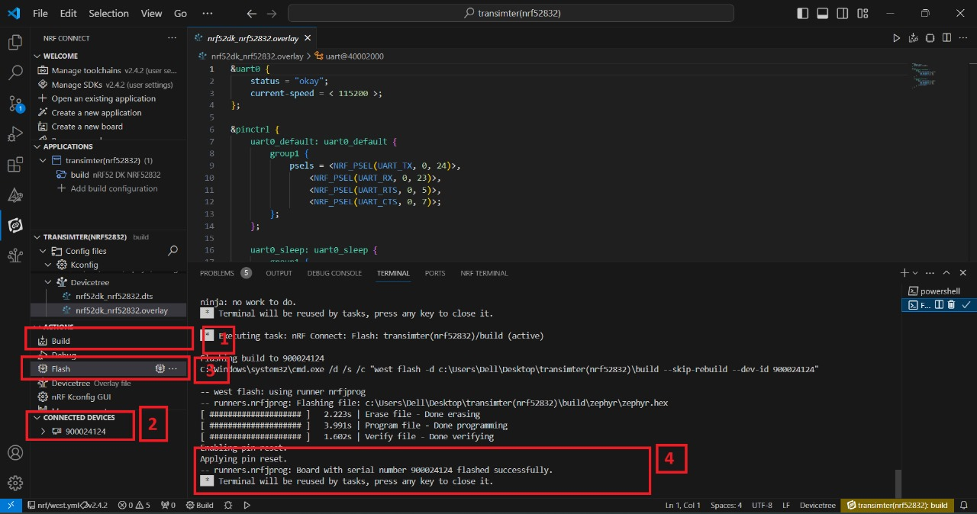

* **STEPS TO PROGRAM THE RECEIVER NODE.**

* Click on the **Open Existing Application [1]** > click on **ble_controller [2]** > **Open [3]** as shown in the picture below.

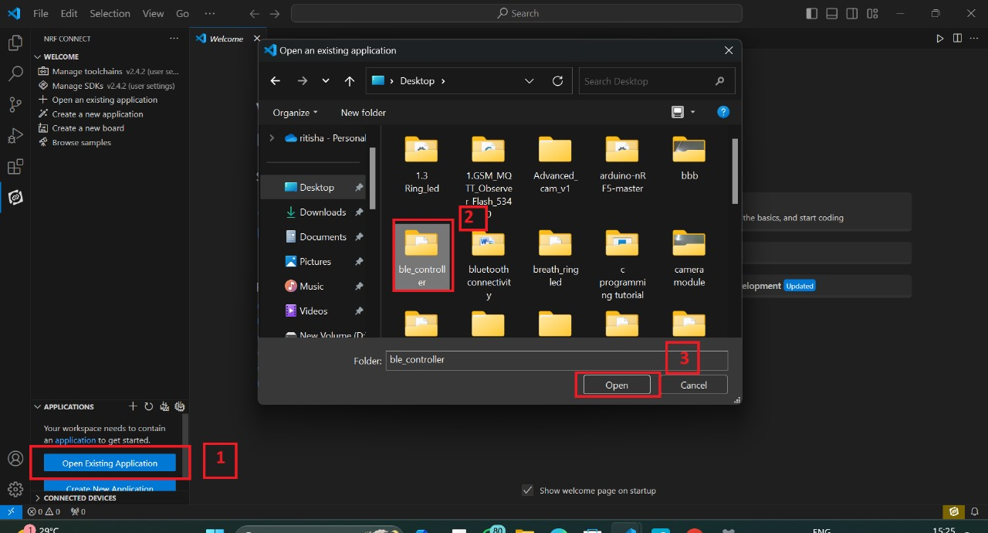

* Click on **Create new build configuration [1]**. Here you can change the board version, if you are using nRF52832, then select **nrf52dk_nrf52832 [2]** or you can change from dropdown menu for another version like nRF52833 etc.
* Click on the Configuration and select **prj.conf [3]** from dropdown menu and then click on the **Build Configuration [4]** as shown below in the picture.



* Go to source file, click **source file [1]** > click on **Application** > click on **src** > click on **main.c [2]**.
* By Clicking on **main.c** file and you will see the code on your screen **[3]**.

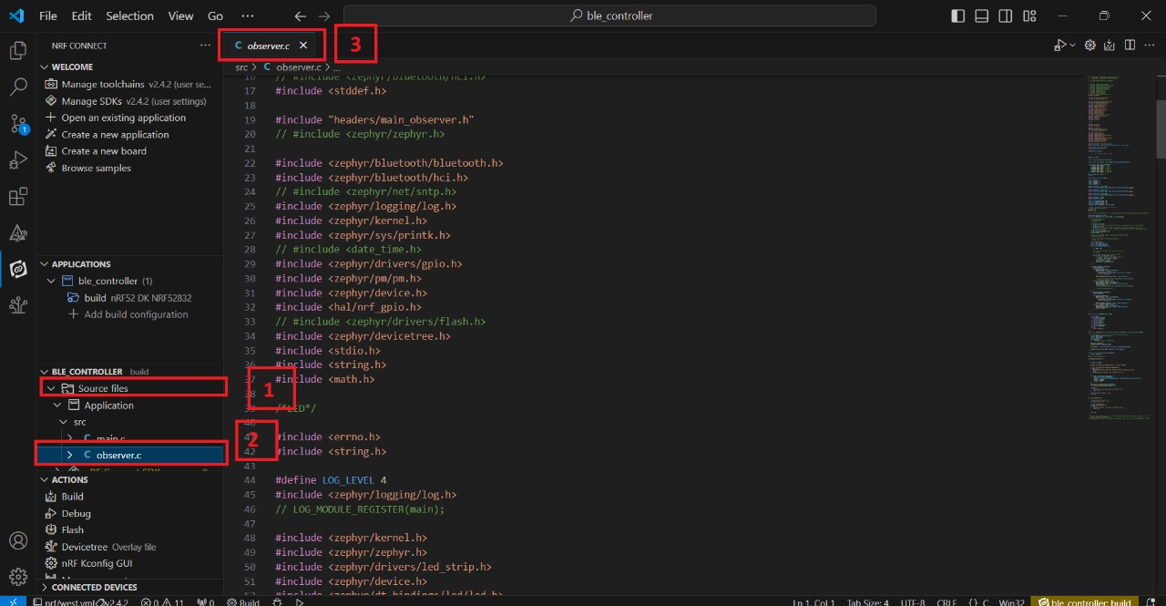

* To configure the prj configuration, click on **Config files [1]** > click on **Kconfig** > click on **prj.conf [2]**.
* The prj configuration will appear on your screen **[3]** as shown in the picture below.

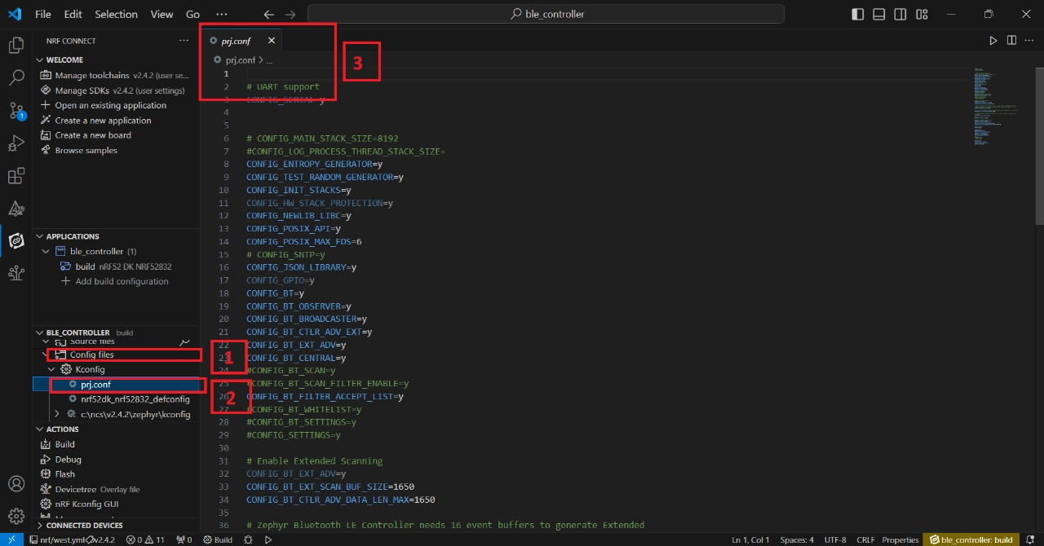

* Click on the **Config files [1]** > click on **Kconfig** > click on **Devicetree [2]** > click on **nrf52dk_nrf52832.overlay [3]**.
* The .overlay file will appear on your screen and add the given code to the .overlay file as shown in the picture given below **[4]**.

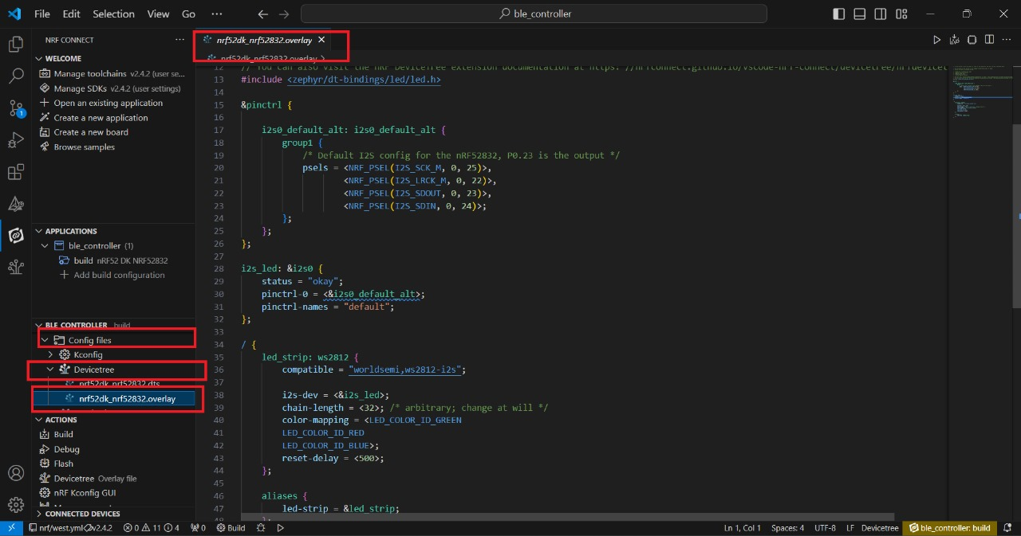

* Click on **Build [1]** configuration again and check the **CONNECTED DEVICES [2]**.
* If device id is visible, then **Flash [3]** the code in Dev Kit.
* If **flashed successfully [4]** message is displayed on serial terminal, then flash process is complete.

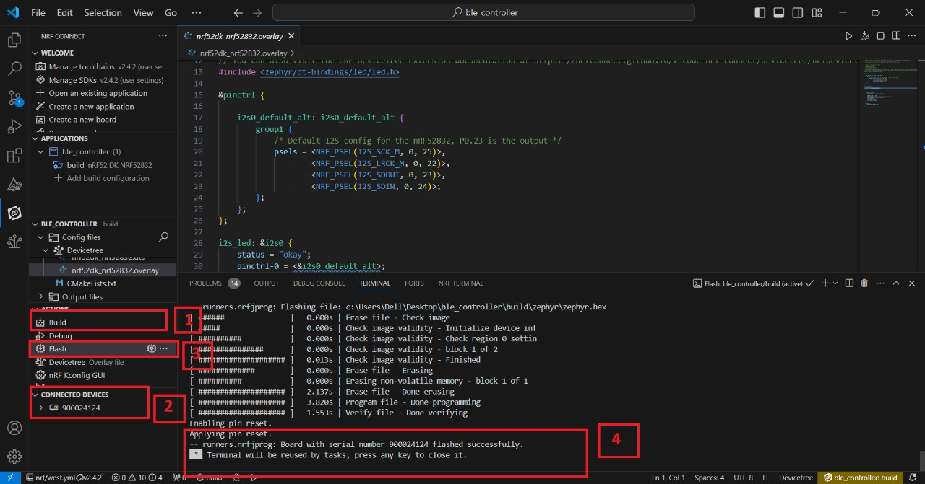

* **PIN CONFIGURATION**

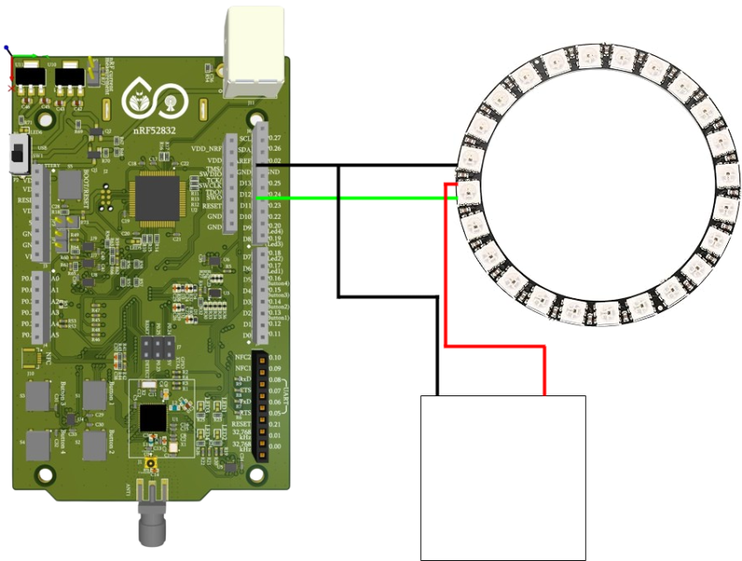

**LED Pins -> Board Pins**

**DI -> P0.23**

**5V -> +ve(External 5V conv.)**

**GND -> -ve(External 5V conv.)**

5v

converter

* **OUTPUT**
* When you press the reset button for 5 seconds the led will glow for the first time and again pressing the button will off the led.
* Also you can change the colour of the led by using more remotes(nodes) as shown below.
* Flash the code to the node with different node id’s.

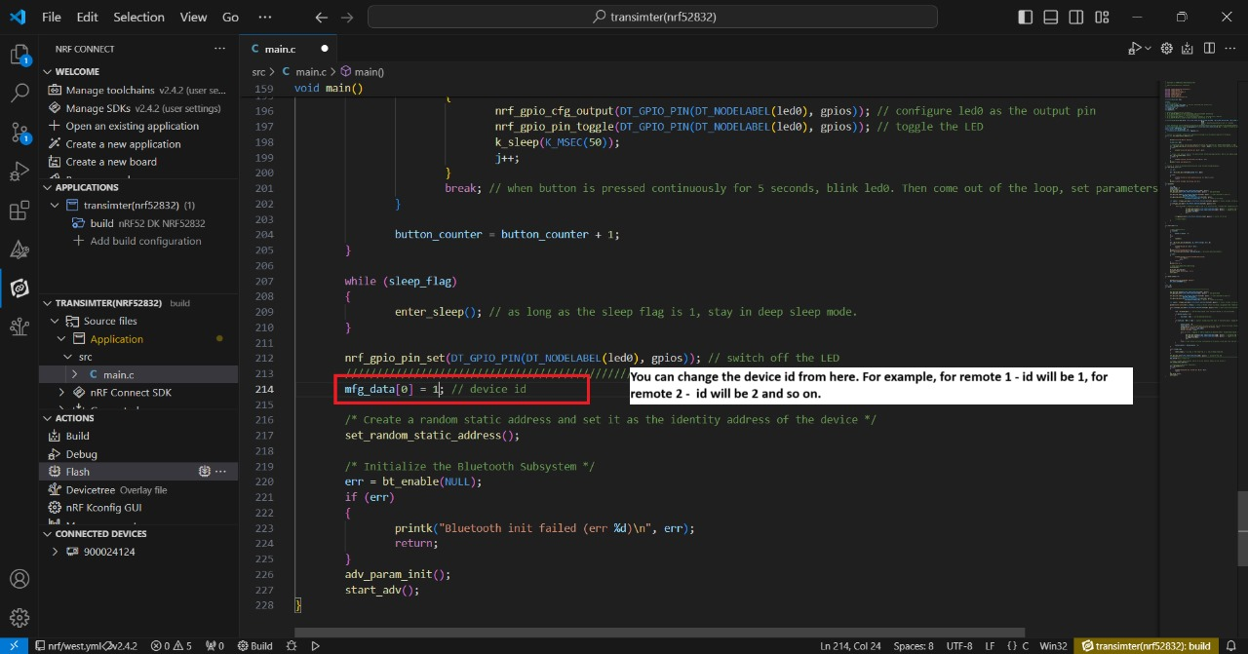

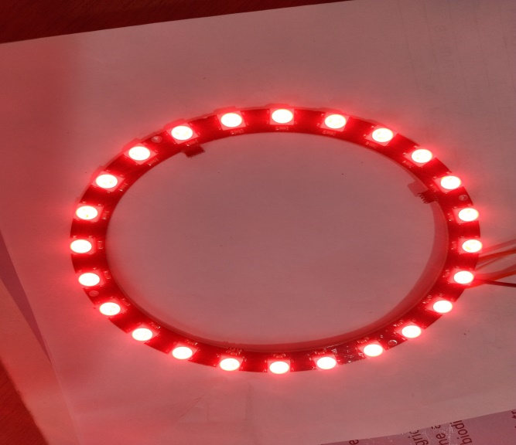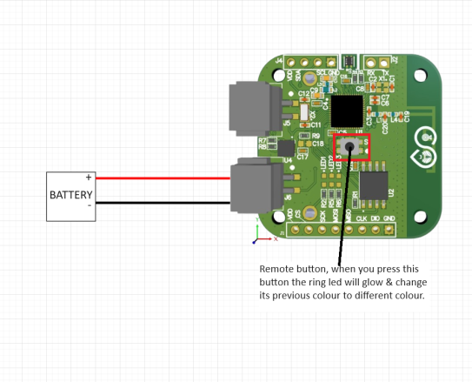

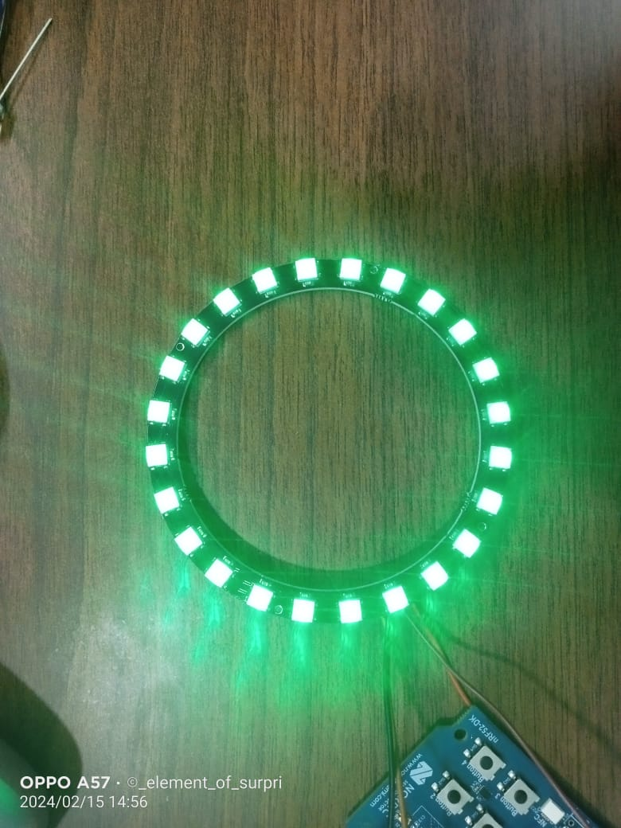

* When using different device Id, the led will change its colour as shown below.